Implementation of planar magnetic drivers for precise sound reproduction

Third Year Individual Project – Final Report

January 2025

Shay Campbell
11079275

Supervisor:
Cheng Zhang

Contents
Implementation of planar magnetic drivers for precise sound reproduction 1
Contents 2
Abstract 3
Declaration of originality 4
Intellectual property statement 5
1 Introduction 6
1.1 Background and motivation 6
1.2 Aims and objectives 7
2 Literature review 8
2.1 Conclusions 8
3 Methodology 8
3.1 Theoretical Development 8
3.2 Design choices 9
3.3 Implementation 9
3.4 Testing 10
3.5 Results and discussion 10
3.6 Analysis 10
4 Conclusion and Future works 10
4.1 Future work 10
References 11
Appendices 11

Word count: X

Abstract
This is abstract text.
Lorem ipsum dolor sit amet, consectetuer adipiscing elit. Maecenas porttitor congue massa. Fusce posuere, magna sed pulvinar ultricies, purus lectus malesuada libero, sit amet commodo magna eros quis urna.
Nunc viverra imperdiet enim. Fusce est. Vivamus a tellus. Pellentesque habitant morbi tristique senectus et netus et malesuada fames ac turpis egestas. Proin pharetra nonummy pede. Mauris et orci. Aenean nec lorem. In porttitor. Donec laoreet nonummy augue.
Suspendisse dui purus, scelerisque at, vulputate vitae, pretium mattis, nunc. Mauris eget neque at sem venenatis eleifend. Ut nonummy.

Declaration of originality
I hereby confirm that this dissertation is my own original work unless referenced clearly to the contrary, and that no portion of the work referred to in the dissertation has been submitted in support of an application for another degree or qualification of this or any other university or other institute of learning.

Intellectual property statement
- The author of this thesis (including any appendices and/or schedules to this thesis) owns certain copyright or related rights in it (the “Copyright”) and s/he has given The University of Manchester certain rights to use such Copyright, including for administrative purposes.

- Copies of this thesis, either in full or in extracts and whether in hard or electronic copy, may be made only in accordance with the Copyright, Designs and Patents Act 1988 (as amended) and regulations issued under it or, where appropriate, in accordance with licensing agreements which the University has from time to time. This page must form part of any such copies made.

- The ownership of certain Copyright, patents, designs, trademarks and other intellectual property (the “Intellectual Property”) and any reproductions of copyright works in the thesis, for example graphs and tables (“Reproductions”), which may be described in this thesis, may not be owned by the author and may be owned by third parties. Such Intellectual Property and Reproductions cannot and must not be made available for use without the prior written permission of the owner(s) of the relevant Intellectual Property and/or Reproductions.

- Further information on the conditions under which disclosure, publication and commercialisation of this thesis, the Copyright and any Intellectual Property and/or Reproductions described in it may take place is available in the University IP Policy (see http://documents.manchester.ac.uk/DocuInfo.aspx?DocID=24420), in any relevant Dissertation restriction declarations deposited in the University Library, and The University Library’s regulations (see http://www.library.manchester.ac.uk/about/regulations/_files/Library-regulations.pdf).

Introduction

Background and motivation
Imagine a world full of ambient noise, without the ability to escape into your own sphere, where the consumption of music was a purely social experience. This was reality up until the 1980s when headphones became widely adopted, dramatically shifting this paradigm. While headphones had been in use for many years prior, primarily for stationary listening, their exponential adoption coincided with innovations in handheld technologies—specifically when Sony’s Walkman hit the market. This device allowed users to untether from home stereo systems and bring their enclosed audio bubble into the outside world. Headphones introduced a drastic shift in audio consumption, offering a personalized sound experience. However, they also altered social dynamics, fostering the creation of ‘personal bubbles’ in urban environments and changing the fabric of public interaction. Despite this impact on social engagement, the technology has proven so useful and indispensable that its benefits outweigh the cost of reduced social interaction for the average person. This is evident in the continued growth of the headphones market. In 2020, the global market was valued at $15.9 billion, and by 2026, it is estimated to reach $45.7 billion—an annual growth rate of approximately X% (consider adding this missing figure for clarity).
Sound quality has been the primary incentive for purchasing audio products, with consumers consistently prioritizing audio performance over factors such as battery life, price, comfort, and ease of use. This trend has remained steady over the past six years, as highlighted in Qualcomm’s State of Sound Report 2021. The exponential growth of the headphone market reflects a rising demand for higher-fidelity audio and greater accessibility to premium sound experiences. However, as consumer expectations for sound quality continue to evolve, so too must the technology that drives these products.
Traditional dynamic drivers, which dominate the headphone market, have long been the standard for audio reproduction. While they are widely available and cost-effective, their design introduces inherent mechanical limitations that can affect sound accuracy. These drivers often produce a non-linear frequency response, leading to unintended coloration of the audio signal. While this characteristic may enhance enjoyment for casual listening, it can compromise accuracy for those who require faithful sound reproduction, such as audio professionals and critical listeners.
This report aims to investigate whether planar magnetic technology can overcome these limitations by providing headphones with the precision and neutrality necessary for high-fidelity sound reproduction. It will explore the functionality of planar magnetic drivers, analysing both their mechanical and electrical properties. The focus will be on headphone design strategies that minimize distortion and enhance clarity, including an evaluation of frequency characteristics. Additionally, the inherent properties of diaphragm materials will be examined to understand their impact on perceived acoustics. By analysing these factors, this research seeks to determine whether planar magnetic headphones can offer a superior alternative to traditional dynamic drivers for applications demanding high-fidelity sound.

Aims and objectives
The aim of this project is to engineer high-quality sound reproduction using planar magnetic technology, the use of a flexible material as a diaphragm suspended between an array of magnets, for low distortion and detailed audio. The report will describe in detail the implementation of the planar magnetic drivers, justifying design choices using physics and electrical derivations, explaining how each choice made is conducive to the aim of the project.
To achieve the aforementioned aim, clear objectives have been defined to limit and focus the scope:
- Firstly, finding a magnet configuration which provides a strong, alternating field at its surface
  - Use simulations to visualise the created field and determine the force it will cause on the diaphragm
- Secondly, determine the relative magnetic field distribution on a set of parallel current carrying traces
  - Use simulations to visualise the created field
- Thirdly, choose a material for the diaphragm of the drivers
- Next, design a serpentine PCB design, aligning the tracks, but more specifically their areas of largest magnetic density, with the magnetic field loops created by the magnet configuration.
  - Ensuring the direction of the current carrying traces matches with the alternating magnetic field of the magnets
- Design and 3D print driver enclosure, which fits the magnet arrays found, and suspends the created PCB between them.
- Test the drivers with a test signal, to ensure they function as expected
- Design an earcup enclosure to house the drivers, with design characteristics for intended output sound.
- Produce and analyse frequency response plots of the headphones.

Report Structure
The report is structured to systematically explore the design and implementation of high-quality planar magnetic headphones. It begins with a Literature Review, analysing existing research on planar magnetic technology and its applications. Following this, the Methodology section outlines the theoretical development and design choices, leading to the Implementation. Testing is conducted to assess performance, with findings presented in the Results and Discussion section. The project also includes an analysis of test data to explain why the system performed how it did. Finally, the Conclusion and Future Work section summarizes key insights and suggests potential improvements for further research.

Literature review

Conclusions

Methodology

Theoretical Development
Sound is caused by the displacement of air molecules due to vibrations. These molecules don’t travel with the sound wave; instead, they move back and forth in place parallel to the direction of the waves propagation. As they do this, they either compress together, compression, or spread apart, rarefaction. This cycle of compression and rarefaction moves through the air as a pressure wave, carrying energy from the source to your ears, where it is interpreted as sound. The difference between the highest and lowest pressure points in a wave is called its amplitude—the greater the amplitude, the louder the perceived sound
Therefore, to create sound, air molecules must be displaced through vibrations. In headphones, this is achieved using a diaphragm—a light, thin, and flexible material that vibrates in response to a force. The diaphragm's motion determines the sound perceived by the ear and is directly influenced by the force acting upon it. Therefore, the accuracy of the perceived sound depends on how precisely an input sound signal is converted into force, which then drives the diaphragm’s motion.
For the diaphragm to create compressions and rarefactions, it must receive a push-pull force. In planar magnetic headphones, this force comes from the interaction of magnetic fields. A static magnetic field is generated by suspending the diaphragm between two arrays of magnets, however, a static magnetic field alone isn't enough—the diaphragm needs a changing force to vibrate and produce sound.
The alternating magnetic field is produced by the traces on the diaphragm, which carry an alternating current. When the AC current flows through these traces, it generates a magnetic field that interacts with the static field from the permanent magnets. This interaction produces a force on the diaphragm, causing it to move back and forth. The strength of this force on any given trace is determine by Fleming’s Left-Hand Rule:
$$\begin{aligned}F=I∙B∙L\#\left(1\right)\end{aligned}$$
Where F is the force felt by the trace, 𝐼 is the current through the traces, 𝐿 is the effective length of the current-carrying conductor, and 𝐵 is the magnetic flux density of the static magnetic field. The total force on the diaphragm in planar magnetic headphones is the sum of the forces on all the individual traces. Since each trace is carrying current and interacting with the static magnetic field from the permanent magnets, we can derive the total force as follows:
$$\begin{aligned}F_{total}=NILB \#(2)\end{aligned}$$

Where variables have their aforementioned meaning, $F_{total}$ is the total force felt by the diaphragm and N is the number of traces subjected to the force.
Understanding how the diaphragm responds to this force is essential in predicting the frequency response and resonance behaviour of the system. Since the external force on the diaphragm is known, we can begin to derive an equation of the motion for the diaphragm as a consequence of this force. The calculations can be simplified due to the absence of free vibrations in the normal operation of planar magnetic drivers, in this case the system can be modelled as a second-order mass-spring-damper system:
$$\begin{aligned}F_{total}(t)=M\ddot{x}+c\dot{x}+Kx\#\left(3\right)\end{aligned}$$

Where $F_{total}$ maintains previous meaning, $M\ddot{x}$ is the inertial force, $c\dot{x}$ is the damping force, representing air resistance and material damping and finally $Kx$ is the restoring force, which represents the restoring tension in the diaphragm. This can be further analysed to find the affects of the force on the system within the frequency domain, by simplifying the differential equation of motion using the Laplace transform:
$$\begin{aligned}L\left\{F_{\text{total}}\left(t\right)\right\}=L\left\{M\ddot{x}+C\dot{x}+Kx\right\}\#\left(4\right)\end{aligned}$$

$$\begin{aligned}F_{\text{total}}\left(s\right)=M\left(s^{2}X\left(s\right)\right)+C\left(sX\left(s\right)\right)+KX\left(s\right)\#\left(5\right)\end{aligned}$$

$$\begin{aligned}F_{\text{total}}\left(s\right)=X\left(s\right)\left(Ms^{2}+Cs+K\right)\#\left(6\right)\end{aligned}$$
We can rearrange to get a transfer function for the frequency response of the system:
$$\begin{aligned}H\left(s\right)=\frac{X\left(s\right)}{F_{\text{total}}\left(s\right)}=\frac{1}{Ms^{2}+Cs+K}\#\left(7\right)\end{aligned}$$

$$\begin{aligned}H\left(s\right)=\frac{1}{M\left(s^{2}+\frac{C}{M}s+\frac{K}{M}\right)}\#\left(8\right)\end{aligned}$$
This we can rearrange to get into a more familiar form and derive our gain, damping ratio and natural frequency of the system:
$$\begin{aligned}H\left(s\right)=\frac{1/M}{s^{2}+2ζω_{n}s+ω_{n}^{2}}\#\left(9\right)\end{aligned}$$

Where 𝜁 is the damping ratio and $ω_{n}$ is the natural frequency of the system.
The transfer function in Equation (9) describes the frequency response of the diaphragm system, showing how it reacts to external forces across different frequencies. It highlights the influence of mass (M), damping (C), and stiffness (K) on the system's behaviour:
Firstly, the natural frequency ($ω_{n}$):
$$\begin{aligned}ω_{n}=\sqrt{\frac{K}{M} }\#\left(10\right)\end{aligned}$$
Determining and knowing the relationship of the natural frequency of the system is paramount to avoiding resonance peaks in the frequency response. Ideally, the systems natural frequency would lie outside the audible frequency range, to prevent resonances, which occur when the excitation frequencies approach the natural frequency of the material.
Secondly, the damping ratio ($ζ$):
$$\begin{aligned}ζ=\frac{C}{2Mω_{n}}\#\left(11\right)\end{aligned}$$
The damping ratio determines how quickly oscillations dissipate after the diaphragm is subjected to an external force, thereby controlling the system's transient response.
Finally, the gain of the System:
$$\begin{aligned}Gain=\frac{1}{M}\#\left(12\right)\end{aligned}$$

The gain relationship clearly indicates that the mass of the diaphragm is inversely proportional to the responsiveness of the system, meaning a lighter diaphragm more efficiently converts the inputted force into motion.
Fundamentally, the functioning of the drivers can be explained using a combination of equation (2), representing the external force felt by the diaphragm and equation (9), showcasing it’s response in the frequency domain due to the force applied. Equation (2) also provides a relationship between the flux density of magnetic field and the force, demonstrating how changes in variables can increase the force applied, similarly equation (9) produces insights, demonstrated in equations (10), (11) and (12) of how changes can be made to variables to affect the systems behaviour. These two fundamental equations will be used to inform the design choices.

Design
Lorem ipsum dolor sit amet, consectetuer adipiscing elit. Maecenas porttitor congue massa. Fusce posuere, magna sed pulvinar ultricies, purus lectus malesuada libero, sit amet commodo magna eros quis urna.

PCB design
The PCB should be designed to maximise the overlap between the magnetic field produced by its tracks and the field loops generated by the magnets. To achieve this, the respective field distributions must be analysed to identify regions of maximum flux density, which will inform the optimal positioning of PCB tracks.
Beyond maximizing field overlap, there are two additional key factors to optimize:
- Minimising PCB mass – A lighter PCB improves control over the diaphragm and increases the system’s gain.
- Maximising impedance – A higher impedance reduces the current required to achieve the same power output, making the headphones easier to drive.
The impedance of the PCB not only affects the efficiency of the system, and how much current is required by the source to drive the load but also has an affect on the damping factor of the headphones. Damping factor is the ratio of the headphones input impedance (load) to the output impedance of the amplifier (source), and it measures how well the amplifier can control the diaphragm of the headphones:
$$\begin{aligned}DF=\frac{Z_{load}}{Z_{source}}\#\left(13\right)\end{aligned}$$

Where DF is the damping factor and $Z_{load}$ is the impedance of the diaphragm and $Z_{source}$ is the impedance of the amplifier. Planar magnetic drivers have a purely resistive load; therefore, their impedance curve is virtually flat, which means a constant current can be drawn to produce the same sound. However, damping factor still matters because even though planar drivers do not exhibit large impedance fluctuations like dynamic drivers, a low damping factor, due to a smaller output impedance load, can still reduce the amplifier’s ability to exert control over the diaphragm. This can result in a looser transient response, how quickly the diaphragm responds to sudden changes to input signal, as the amplifier may struggle to properly damp unwanted motion of the diaphragm after the signal stops.
To increase the impedance of load, the width of the current carrying traces on the diaphragm need to be reduced, and the length of the total trace should be increased. The minimum width and separation of the traces on the PCB is determined by the manufacturers capabilities, in this case University of Manchester PCB facilities. UOM facilities have a restriction of 0.3mm trace width and separation. Utilising the minimum width ensures we maximise the resistance according to:
$$R=\frac{ρ⋅l}{w⋅t}$$
Where R is the resistance, $ρ$ is the resistivity, l is the length, w is the width and t is the thickness of the trace. By reducing the trace width, we increase trace resistance whilst also allowing more traces to fit on the PCB, therefore increasing resistance again.
Tracks are a parallel set of traces on a PCB, the relative shape of a tracks magnetic field distribution will be dependent on their thickness and separation which we have defined as 0.3mm. Knowing this, the we can begin to derive the field distribution of the tracks by first finding the magnetic flux density B of an individual current carrying trace, which can be defined using Amperes-law:
$$B=\frac{μ_{0}I}{2πr}$$
Where B is magnetic flux density, $μ_{0}$ is the permeability of free space, I is the current through the trace and r is the radius of the trace. Since we are primarily interested in the relative field distribution, the magnitude of the current, I, and the number of traces in a track can be disregarded for this analysis. To find the flux density at any given point due to multiple traces, we apply the principle of superposition. This means the total magnetic field at any given point is the vector sum of the individual magnetic fields at said point. This can be visualised using a script to plot the field distribution in python for an arbitrary amount of traces per track:
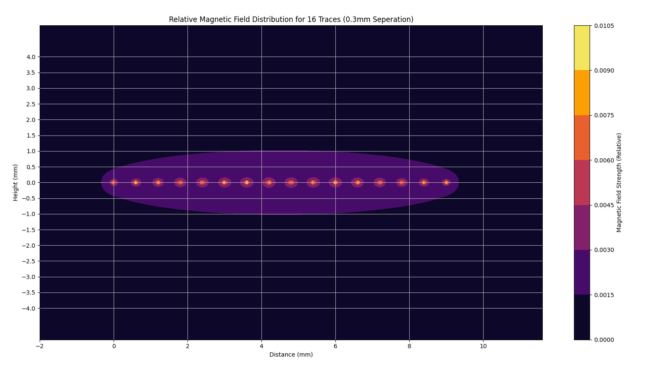
Figure 1: Relative Magnetic Field Distribution For a Track
This figure demonstrates the relative field distribution for any implementation of tracks, showing here 16 point traces each carrying a current, producing a magnetic field around them, the field distribution is symmetrical around the centre of the traces, which is is expected due to the symmetrical arrangement of the traces themselves. The centre exhibits the greatest summation of vector magnetic fields, which logically results being in the region of the greatest number of traces. This figure, suggests that each track should be centred directly beneath each magnetic field loop produced by the magnets, to achieve maximum field overlap and therefore maximum interaction, without wasted efficiency.
While the optimal track positioning for maximum efficiency is established, the track configuration for diaphragm movement must be defined. The diaphragm is suspended in an alternating magnetic field, with adjacent magnetic field loops created by the magnets acting in opposite directions. To complement this setup, the current direction in the tracks must alternate as well. The tracks follow a serpentine layout, alternating current direction with each fold, ensuring that all traces in a track carry current in the same direction. Adjacent tracks, however, carry current in opposite directions. This arrangement ensures that the magnetic fields generated by the tracks complement the alternating field loops from the magnets, resulting in a uniform force on the diaphragm. Using the predefined trace width and separation, alongside the magnet length of 50mm, the serpentine configuration can be visualized in Python:

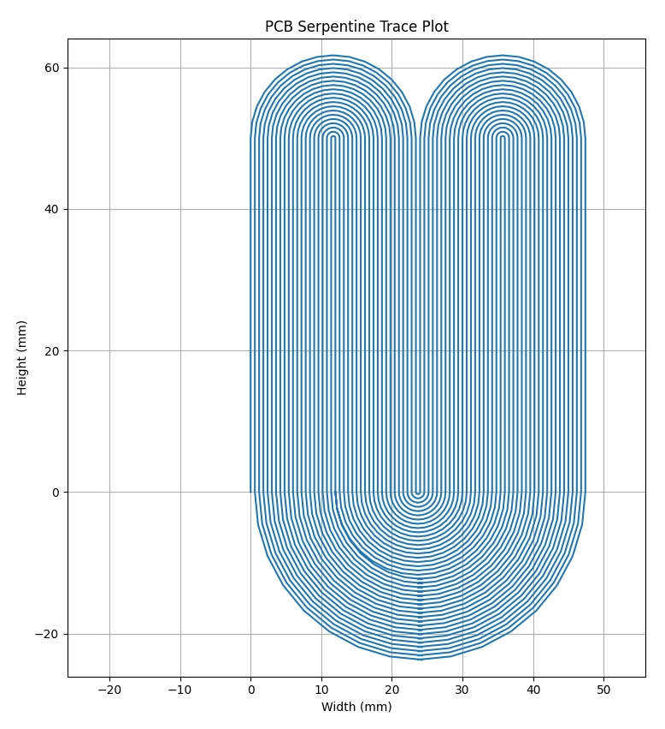
Figure 2: Serpentine trace plot
Figure 2 shows the theoretical design of the PCB, with an arbitrary number of traces per track. The exact number of traces per track will be determined once we calculate the magnetic field loop width created by the magnets. Since the audible frequency range is up to 20 kHz, our design does not need to account for high-frequency signals. Therefore, traces can be routed close to each other without concern for crosstalk or interference causing noise in the sound signal, as frequencies above 20 kHz are inaudible. However, it’s always good practice to take precautions. Since bends are required, the best approach is to ensure they are rounded, preventing trace width variation along the bend, which could cause impedance changes and result in signal reflections.
The subsequent phase involves selecting a suitable substrate material for the PCB. Given the application's requirement for flexibility, minimal inertia a polyimide-based flexible circuit is the optimal choice since they provide flexibility alongside a low mass. Additionally, polyimide based PCBs offer a strong textile strength, meaning they are resistant to warping, providing flexural endurance, which is essential in creating consistent sound reproduction, since it mitigates the chances of resonance peaks at altering locations. In combination the flexibility and low mass of PCBs made from this material ensure the diaphragm's dynamic response is highly sensitive to the input signal, thereby maximising the system's gain, as described by the relationship shown in equation (12). Furthermore, employing a low-mass substrate directly influences the damping factor, demonstrated in equation (11), a higher damping factor allows oscillations to dissipate quickly after the input signal changes, effectively meaning the amplifier has more control over the movement of the diaphragm. This enhanced control is crucial for accurately reproducing transient signals and maintaining stability. The flexible PCB printing capabilities of the University provided us with Kapton as the PCB material, ensuring both high flexibility and low mass while retaining the mechanical strength needed for consistent performance.

Magnet design
The sound quality of the drivers is highly dependent on the magnet configuration, since the magnet configuration directly corresponds to the force felt by the diaphragm. To ensure less distortion a larger force is required, as a larger force maintains tighter control over the diaphragms movement, allowing it to effectively stop and start the diaphragms movement in more closely in response to the input signal. Using equation (2), it is evident that the force can be increased by increasing the magnetic flux density B, this is ideal since less current is needed for a given diaphragm movement. The diaphragm has a fixed resistance, therefore the power required to drive our system is proportional to the square of the current, meaning less power is required to drive the system according to equation (13):
$$\begin{aligned}P∝i^{2}R\#\left(13\right)\end{aligned}$$
A Halbach array is an ideal magnet configuration for this use case because it maximises the magnetic flux density on the side toward the diaphragm, whilst minimising it on the other side, this is due to its alternating magnet orientations which effectively traps the field on one side whilst creating alternating magnetic field loops.
This is useful as the magnetic flux density that would normally be wasted in air is redirected towards the diaphragm increasing efficiency, mean whilst it reduces electromagnetic interference with surrounding technologies.
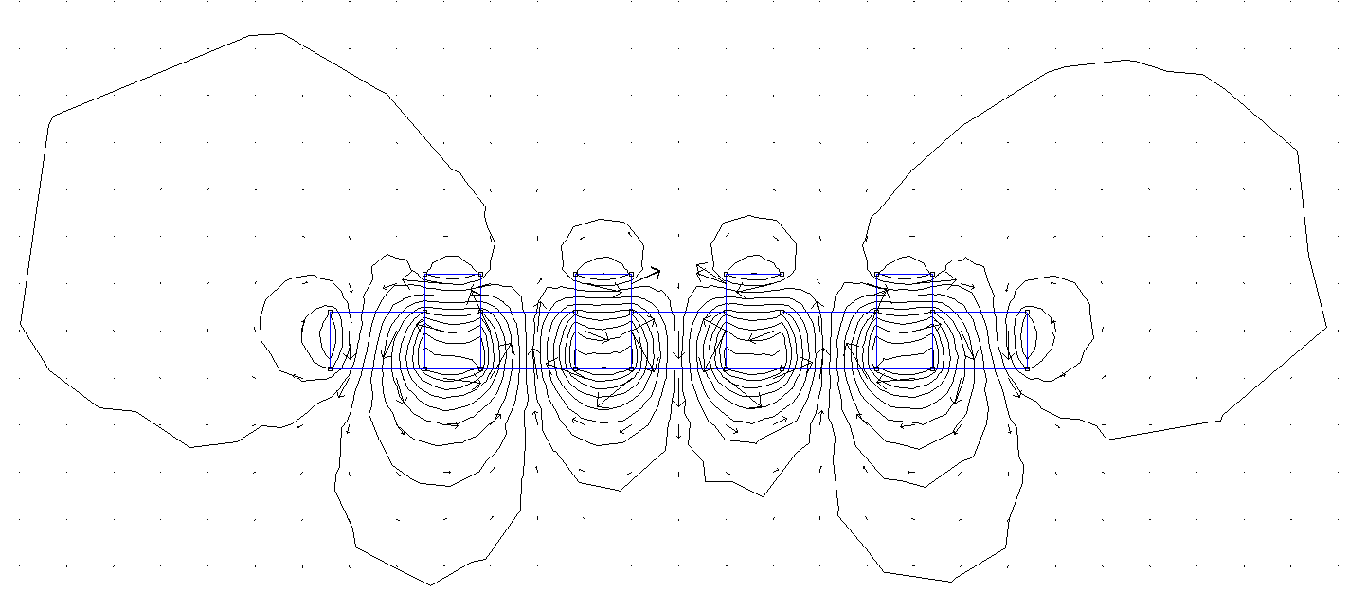
Figure 3: Magnetic field distribution of 0mm gap Halbach array
Figure 1 shows the magnetic field distribution of a Halbach array, with a strong localised field on the bottom, represented by the higher density of magnetic field lines. The vector arrows indicate the direction of the magnetic field at each point, showing the alternating behaviour of the magnetic field loops
In practice, this configuration will be two arrays opposite each other, aligned to superpose their magnetic fields:
Figure 4: Flux density plot of 2 row, 0mm gap Halbach array
Figure 2 displays the magnetic flux density as a colour density plot, where the darker colours represent a higher magnetic flux density B. From this plot it is evident that there will be four distinct loops with high flux density close to their surface, with a peak flux density of 0.93 T. To truly interpret the effect these fields will have on the movement of the diaphragm, the tangential flux density plot at the middle of the air gap should be derived, the tangential flux density plot will show the shape of the flux density which the field of our traces will interact with.
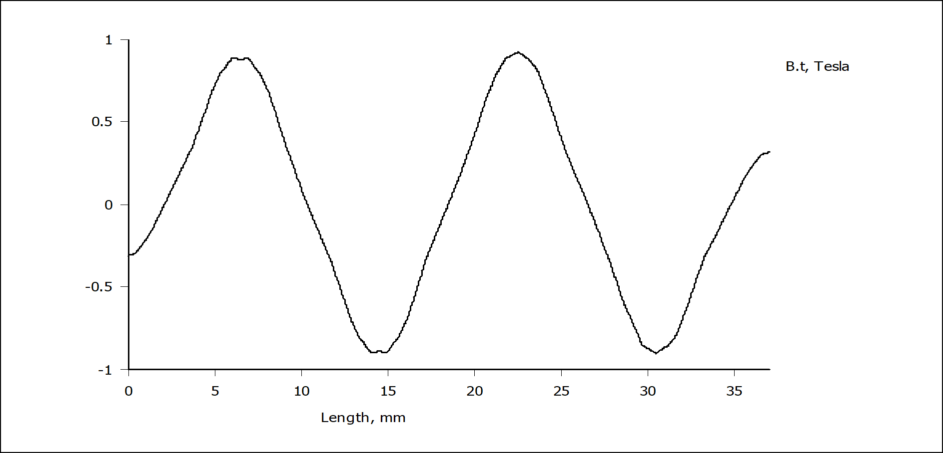
Figure 5: Tangential flux density plot of 0mm gap, 2 row Halbach array
Figure 3 allows us to easily visualise the alternating magnetic field in each loop, alternating between $±0.9 B\hat{t}$ .
This configuration produces the strongest magnetic field at it’s surface but due to the proximity of the magnets with no gap between them, though the width of their magnetic field loop is smaller than if they had a gap between, in this case the loop is 8mm wide. This is important when we begin to consider the fundamentals of our design: The movement of the diaphragm is caused by the interaction between the field created around it’s tracks (parallel traces) and the magnetic field loop created by the magnets, it was previously justified that the trace width and the gap between traces are both 0.3mm, therefore we can use the magnetic loop width to determine the number of traces which can fit into it:
$$\begin{aligned}\text{Magnetic field loop wid}\text{t}\text{h}=0.6n-0.3\#\left(14\right)\end{aligned}$$

$$\begin{aligned}\text{8}=0.6n-0.3\#\left(15\right)\end{aligned}\begin{aligned}\text{Magnetic field loop wid}\text{t}\text{h}=0.6n-0.3\#\left(14\right)\end{aligned}$$
$$n=\frac{8.3}{0.6}=13.83$$
From equation (15) in this configuration only about 13 traces can fit within one magnetic field loop, to increase the amount of traces per track, the field loop width would need to be increased, which means a separation would have to be implemented between the magnets. The benefit of increasing the number of traces per track, is firstly due to an increase in load resistance as justified early but also since it will give a more even distribution of current and therefore force across the PCB. However, to introduce a gap and maintain it would require support for the magnets, this will be implemented using a 3D printed enclosure, the minimum accuracy of the 3D printing at the University of Manchester is 2mm, so to ensure the maximum amount of traces per track whilst also maintaining the field strength produced by the magnets the minimum width constraint will be used, this can be visualised:
Figure 6: Flux density plot of 2 row, 2mm gap Halbach array
This figure shows a slightly different configuration, implementing a gap between the magnets with the aim to increase the width of the individual field loops, this setup produces a loop with a 12mm gap, using equation (15), this means we are now able to fit 20 traces in a track, which is 7 more then previously, an additional 7 traces per track with four tracks in total for each loop, this means an additional 28 lengths of 50mm traces, which will increase the resistance of our circuit. In this figure we can also see more clearly than in the last one, that the area of highest magnetic flux density is concentrated at the centre of the loop, this is relevant since referring back to figure 1, the relative magnetic field distribution for a track, it is evident that the magnetic field is also concentrated at the centre of the tracks and peaks in the same location as seen in the field loops produced by the magnets. This alignment ensures maximum force on the PCB. The tangential field can be visualised for this configuration

Nunc viverra imperdiet enim. Fusce est. Vivamus a tellus.
Pellentesque habitant morbi tristique senectus et netus et malesuada fames ac turpis egestas. Proin pharetra nonummy pede. Mauris et orci.
Aenean nec lorem. In porttitor. Donec laoreet nonummy augue.
Suspendisse dui purus, scelerisque at, vulputate vitae, pretium mattis, nunc. Mauris eget neque at sem venenatis eleifend. Ut nonummy.

Implementation

Magnets Implementation
Aenean nec lorem. In porttitor. Donec laoreet nonummy augue.
Suspendisse dui purus, scelerisque at, vulputate vitae, pretium mattis, nunc. Mauris eget neque at sem venenatis eleifend. Ut nonummy.

PCB implementation
Lorem ipsum dolor sit amet, consectetuer adipiscing elit. Maecenas porttitor congue massa. Fusce posuere, magna sed pulvinar ultricies, purus lectus malesuada libero, sit amet commodo magna eros quis urna.
Nunc viverra imperdiet enim. Fusce est. Vivamus a tellus.
Pellentesque habitant morbi tristique senectus et netus et malesuada fames ac turpis egestas. Proin pharetra nonummy pede. Mauris et orci.

Testing

Results and discussion

Analysis

Conclusion and Future works
Lorem ipsum dolor sit amet, consectetuer adipiscing elit. Maecenas porttitor congue massa. Fusce posuere, magna sed pulvinar ultricies, purus lectus malesuada libero, sit amet commodo magna eros quis urna.
Nunc viverra imperdiet enim. Fusce est. Vivamus a tellus.
Pellentesque habitant morbi tristique senectus et netus et malesuada fames ac turpis egestas. Proin pharetra nonummy pede. Mauris et orci.
Aenean nec lorem. In porttitor. Donec laoreet nonummy augue.
Suspendisse dui purus, scelerisque at, vulputate vitae, pretium mattis, nunc. Mauris eget neque at sem venenatis eleifend. Ut nonummy.

Future work
Lorem ipsum dolor sit amet, consectetuer adipiscing elit. Maecenas porttitor congue massa. Fusce posuere, magna sed pulvinar ultricies, purus lectus malesuada libero, sit amet commodo magna eros quis urna.
Nunc viverra imperdiet enim. Fusce est. Vivamus a tellus.
Pellentesque habitant morbi tristique senectus et netus et malesuada fames ac turpis egestas. Proin pharetra nonummy pede. Mauris et orci.
Aenean nec lorem. In porttitor. Donec laoreet nonummy augue.
Suspendisse dui purus, scelerisque at, vulputate vitae, pretium mattis, nunc. Mauris eget neque at sem venenatis eleifend. Ut nonummy.

References
Put references here.

Appendices
A Project outline
Project outline as submitted at the start of the project is a required appendix. Put here.

B Risk assessment
Risk assessment is a required appendix. Put here.

C XXXX – etc.

